The Emmaus Journey to Openness Luke 24:13-35 26 April 2020
Julian Templeton

“And he asked them, ‘What are you discussing with each other as you walk along?’” (Luke 24:17)

Have you ever noticed that there can be a special openness between people when they walk and talk together? It may be due to the natural rhythm and action of walking. It may be due to going in the same direction with a common destination. Whatever it is, I have found that I have been especially open to listening when walking with others. I remember the walk that 5 of us from St John’s Church did with members and friends of the Svitavy Church through a forest in Bor u Skutče in the Czech Republic in May 2018. I remember how I talked with many people as we walked together. Even now, recalling that easy walking and talking with companions reminds me that under the current restrictions communal activities like this are no longer possible in the same way. For instance, walking at least two meters apart, perhaps wearing a face mask, has a rather different feel to it, a less open feel; and that loss of openness is a cause for regret. However, I am able to speak to you now; you can see and hear me, and I can see some of you, through the wonders of digital internet communication. This open channel of communication is a cause for celebration!

In the passage from the Gospel According to Luke that was read to us, Cleopas and his companion do not appear to begin their journey with a very open frame of mind. I say this because in the two verses that precede our reading, the women who tell them and the apostles that Jesus’s tomb is empty, and that Jesus is alive, are not believed (24:11). It is later on this same day that two of them set out for the village of Emmaus, about seven miles from Jerusalem. As they walk along, they talk—and argue—about the events that have happened in Jerusalem in the past few tumultuous days. As they do so, Jesus comes along and walks with them. But “…something prevented them from recognizing him.” (24:16) This is a telling comment by Luke. Here was someone they knew very well, their own Rabbi; but probably because they were convinced that Jesus was dead, their minds were closed to seeing what was there before their very eyes. Sometimes we see only what we expect to see and are blind to the reality in front of us. Then Jesus asks them: “What are you discussing with each other as you walk along?” (24:17) They stop still, with their faces full of sadness, and Cleopas says that they are talking about Jesus of Nazareth, who by his powerful deeds and words proved himself to be a prophet. The religious leaders handed him over to be crucified and he was sentenced to death. But just this morning some women followers amazed them by saying that Jesus’s tomb was empty and reporting a vision of angels who told them that Jesus was alive.

(share screen with picture, The Way to Emmaus by Robert Zünd)

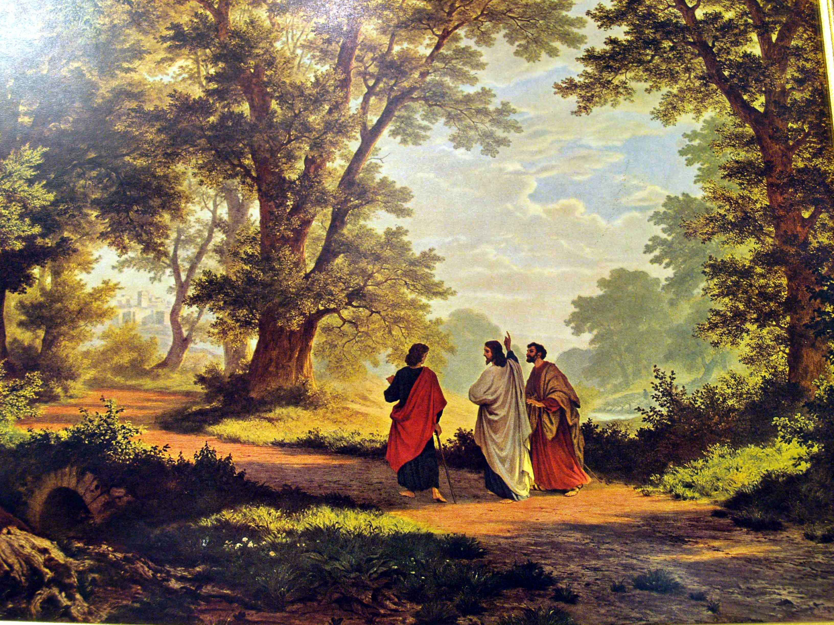

A reproduction of this painting, The Way to Emmaus by Robert Zünd, hung on the wall of my maternal grandparents’ house. As a small child I did not know what the picture was about, but I remember gazing at the figures walking through the grove of enormous trees and finding it very calming. The reproduction you can see looks to me to be a photograph of the original painting, but one that has excluded some of Zünd’s framing oak trees in order to focus on the three human figures near the centre.

Robert Zünd was born in Lucerne, Switzerland, in 1812. He studied painting in Geneva and Paris. In 1863 he settled on the outskirts of Lucerne and rarely left for any extended period of time after that. Zünd's art is distinguished by a special closeness to nature and a highly naturalistic detailed style. His passions were mainly for idyllic landscapes around Lucerne. Between 1867 and 1877 his religious faith began to appear as biblical motifs in his pictures. Zünd finished his painting entitled Der Gang nach Emmaus (The Way to Emmaus) in 1877. Some of us discussed this painting via Zoom in a Bible Study on Wednesday evening. The only part of the painting that attempts to reproduce the original biblical setting would seem to be the dress of the three figures; otherwise it appears to tell us more about 19th century Lucerne than it does about 1st century Palestine. But that in itself speaks volumes. As already mentioned, Robert Zünd had a religious faith and the fact that Christ is depicted walking with the two disciples through an oak forest near Lucerne suggests that, for the artist himself, the risen Christ walks and talks with those willing to listen to him still today. In the original story what Jesus is telling the two disciples, with his right hand extended upwards, is that the suffering and death of their beloved Rabbi is not the disaster they had assumed. Rather, he asks them, “Was not the Messiah bound to suffer in this way before entering into his glory? Then, starting from Moses and all the prophets, he explained to them in the whole of scripture the things that referred to himself.” (24:26-27). In other words, this is a peripatetic sermon; it is the Word of God expounded while walking.

Most journeys eventually reach their destination, and so did this one. The three of them arrive at Emmaus, with Jesus intending to go on further. But the two disciples press him,

‘Stay with us, for evening approaches and the day is almost over.’ So he went in to stay with them.

(change painting to The Supper at Emmaus, Caravaggio)

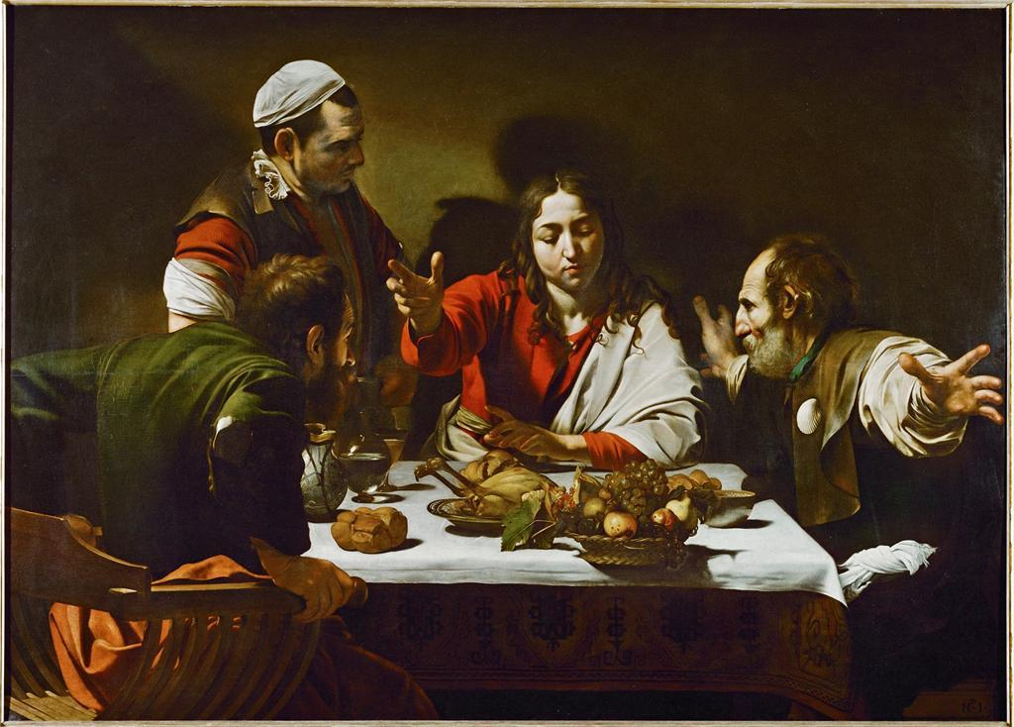

And when he had sat down with them at table, he took bread and said the blessing; he broke the bread, and offered it to them. Then their eyes were opened, and they recognized him; but he vanished from their sight. They said to one another, ‘Were not our hearts on fire as he talked with us on the road and explained the scriptures to us?’ (24:29-32)

This painting is The Supper at Emmaus by Caravaggio. I have seen the original at the National Gallery in London. I think it vividly captures the surprise of the two disciples: the one on the left looks like he is about to jump out of his chair; the one on the right extends his arms out wide in startled surprise. They had previously heard the Word of God but only when Jesus breaks bread do they recognise him.

Now we begin to realise what was happening during that walking and talking together. Cleopas and the other disciple were not only moving on foot with their companion, they were also being moved within. Jesus was preparing them to believe again. He was gradually opening their hearts and minds by reminding them that what the scriptures said about himself. But it is only in retrospect, only after they had experienced divine revelation, that the two disciples recognise that their hearts were on fire. They recognise that they were affected and thus prepared to see what they previously could not see when they were walking and talking with him: that the one who broke bread was Jesus himself.

(stop screen-sharing)

We cannot yet know how the Covid-19 virus will affect our two nations of Czechia and the United Kingdom, along with our European neighbours and the nations of the world. What we do know from personal experience is how we have been affected by the uncertainty and anxiety that it has brought. The good news I have to share with you today is that alongside that uncertainty and anxiety there is a yet greater and more enduring power that can affect us if we would open ourselves to it. Jesus is opening our hearts and minds to the scriptures, moving us within, and preparing us to believe again. We are being prepared to believe that uncertainty and anxiety are not the final words: assurance and faith are. Uncertainty and anxiety close us off from one another, and while they may be natural initial reactions, they ought not to shape our enduring attitude. Rather, we as the Church are called to share in Jesus’s assurance and faith that God loves us and the world he has made, and he is guiding all things through providence to his intended fulfilment. God calls us to journey with Jesus. God challenges us to let Jesus open us to the ‘new normal’ of generosity and caring and love.

I invite you to join me in the following symbolic action. Imagine that in one hand you are holding your uncertainties. And imagine that in the other hand you are holding your anxieties. Gradually turn over the first hand and let go of your uncertainties. Gradually turn over the second hand and let go of your anxieties. Now, turn both hands back over with your palms facing upwards. Your hands are now empty. Ask God to fill one hand with enough assurance, and the other hand with enough faith, as you need today.

Thanks be to God.

Let us respond to the Word of God with our next Hymn ‘Through the love of God our Saviour, all will be well’, this will be preceded by a prelude by Richard Harvey on the Welsh tune Ar hyd y nos.

